Weekly Documentary of 3 types of Plants

Justine Rey Quiñones

Mrs. Jofe Marie Garvez

Week 1

Herbal

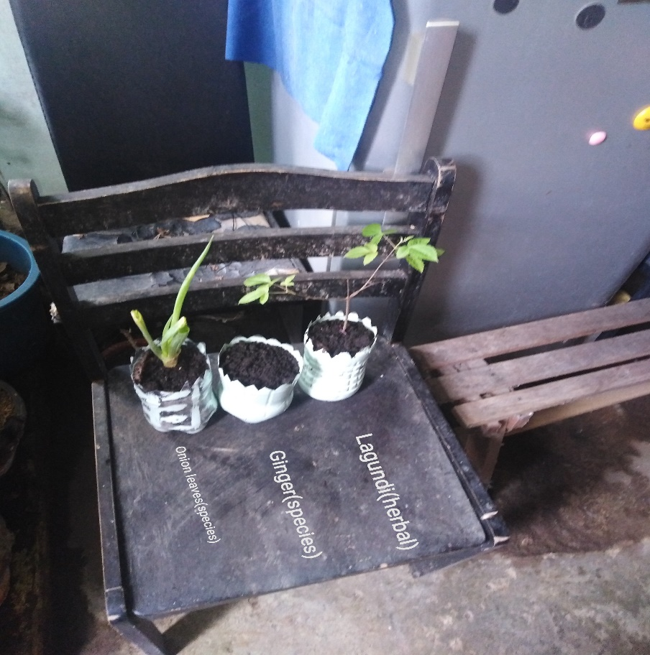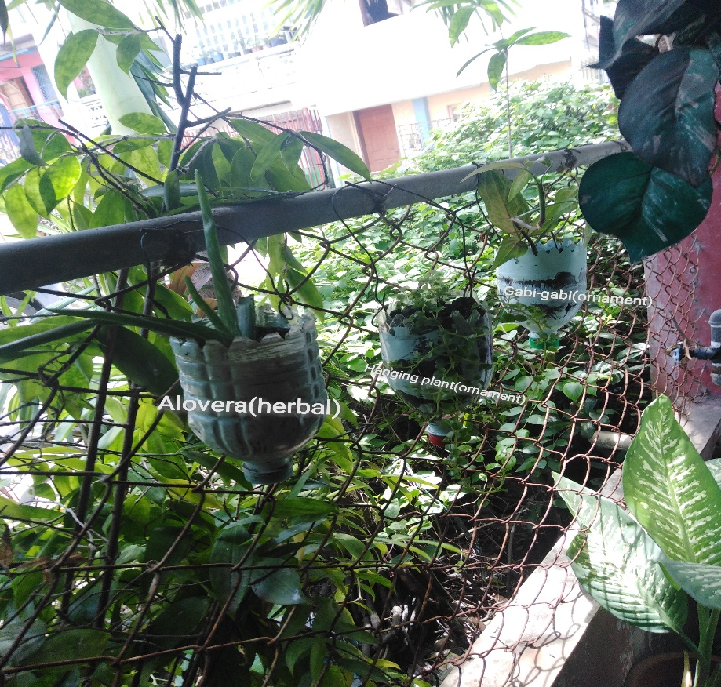

Spices

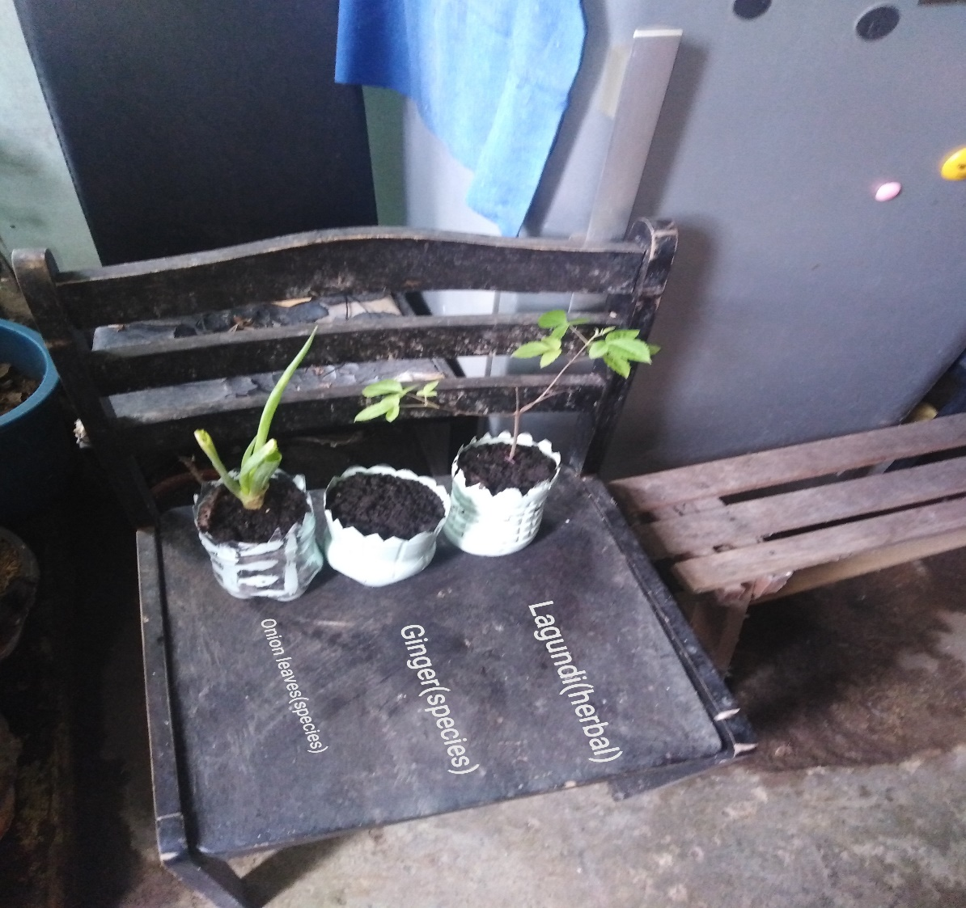

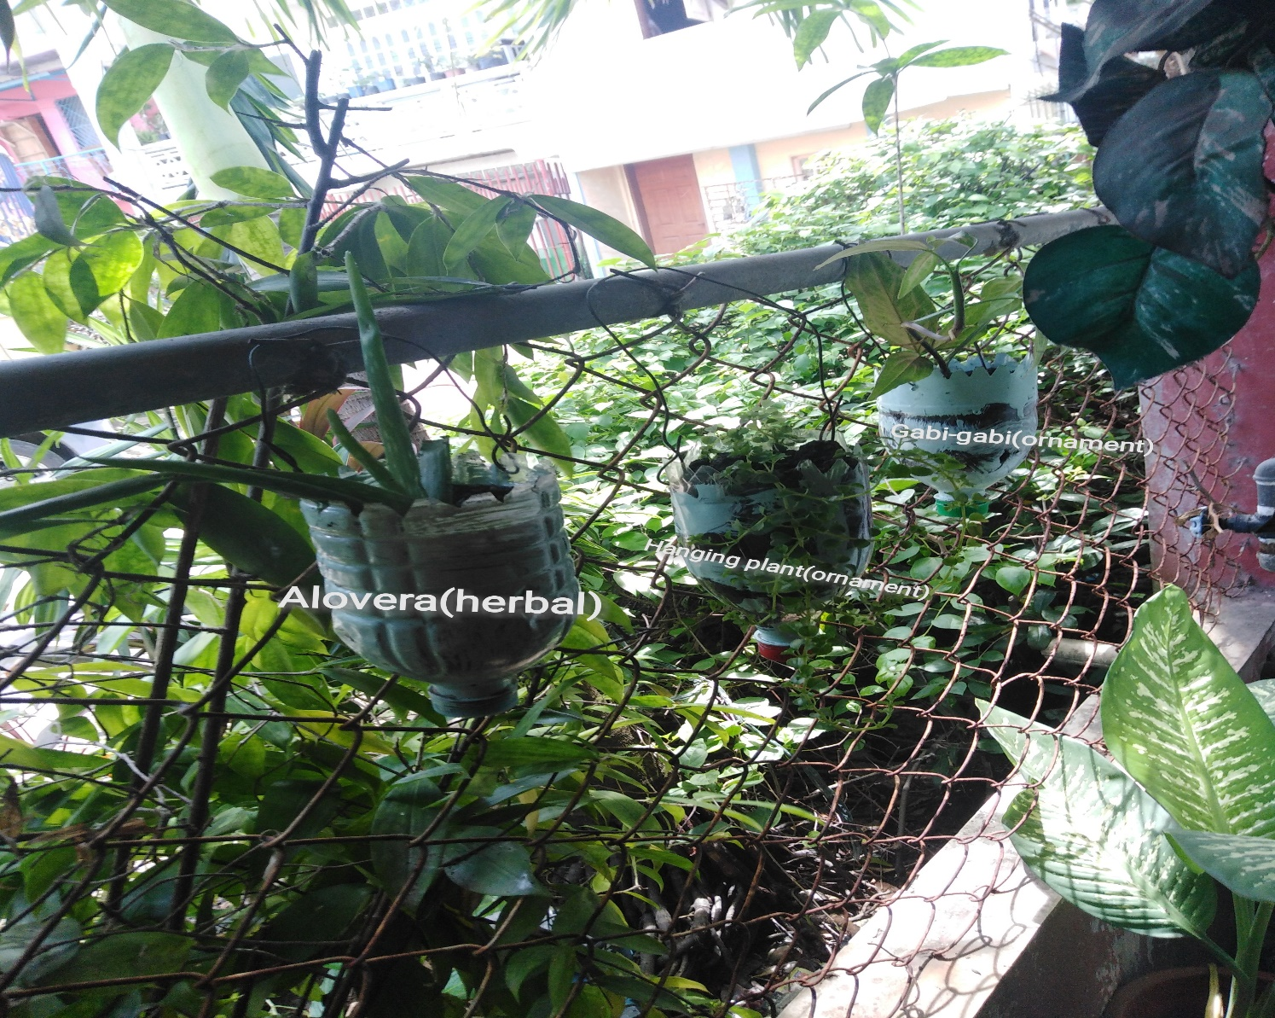Ornamental

Week 2

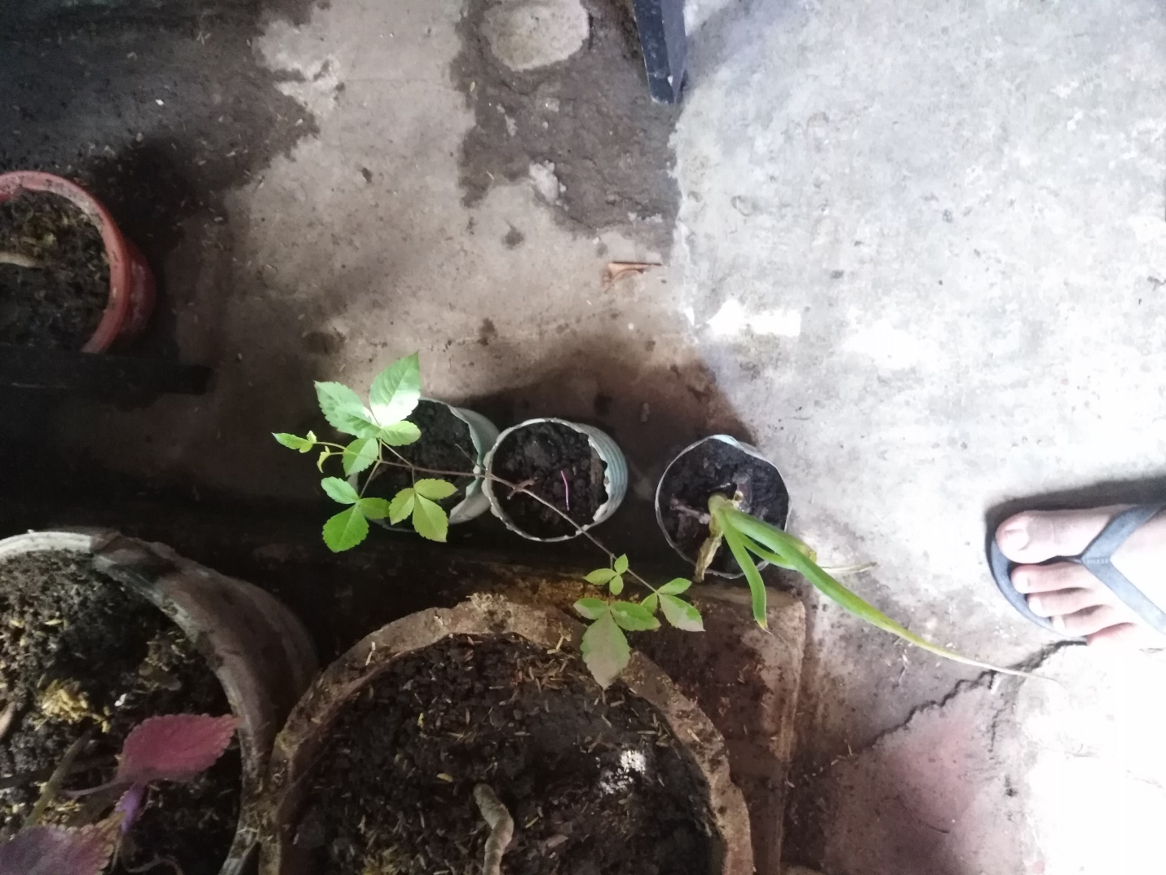Spices

Green Onions

Ginger

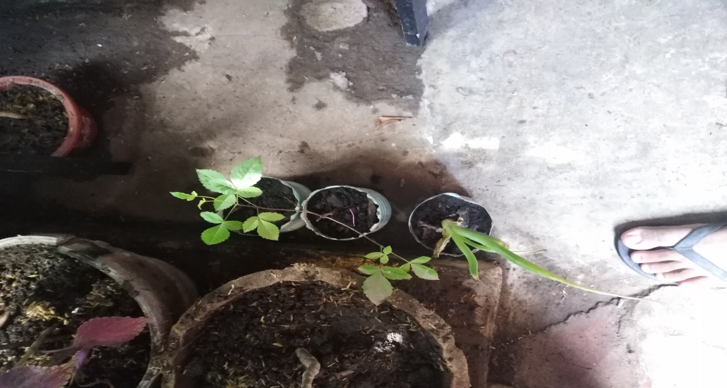Herbal

Lagundi

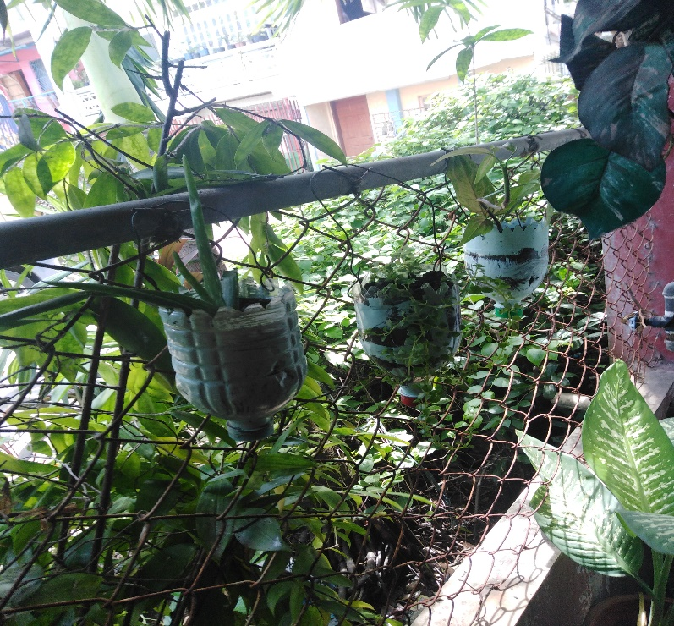

Aloe Vera

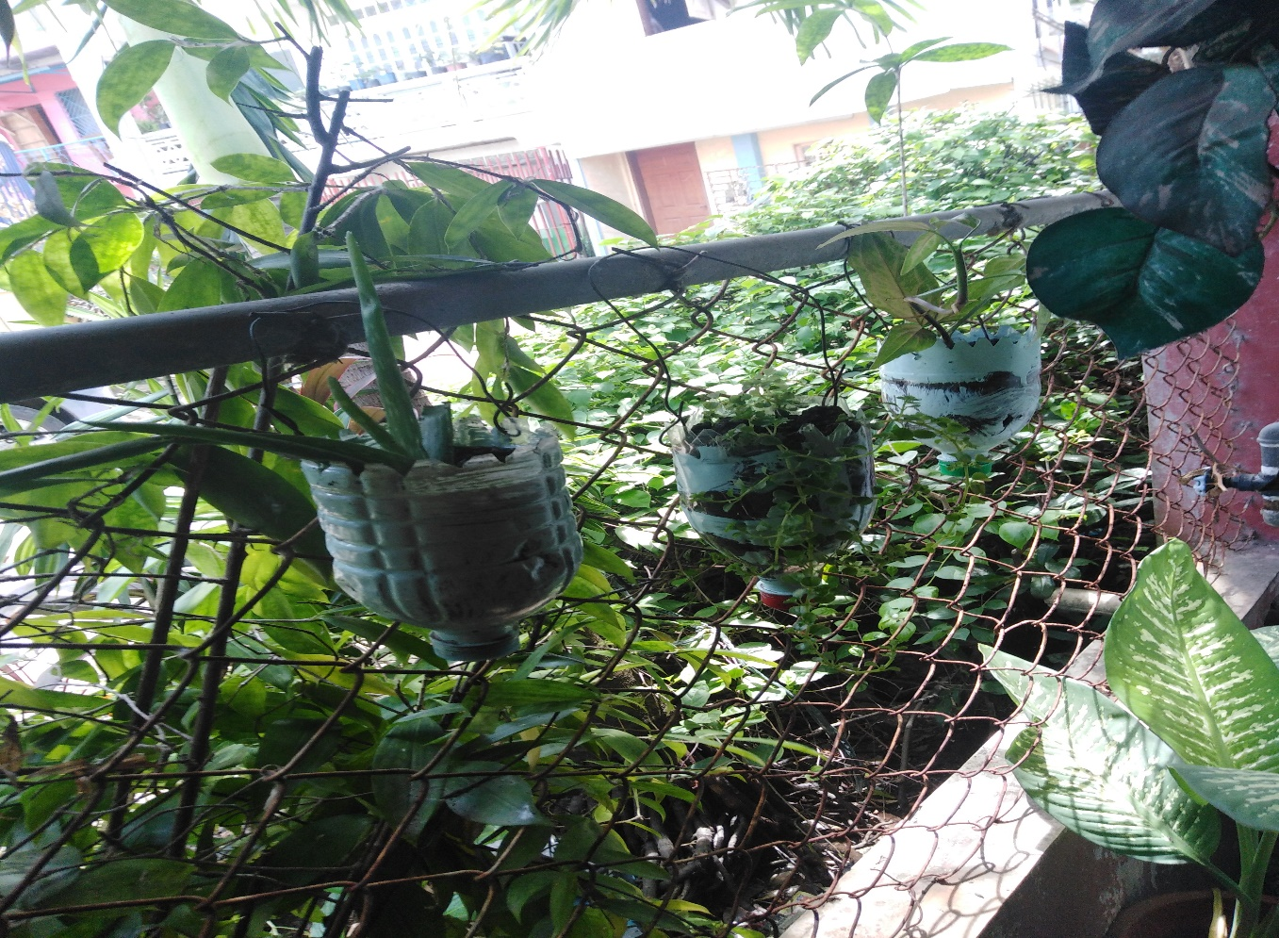Ornamental

Gabi – gabi

Hanging Plant

Week 3

Spices

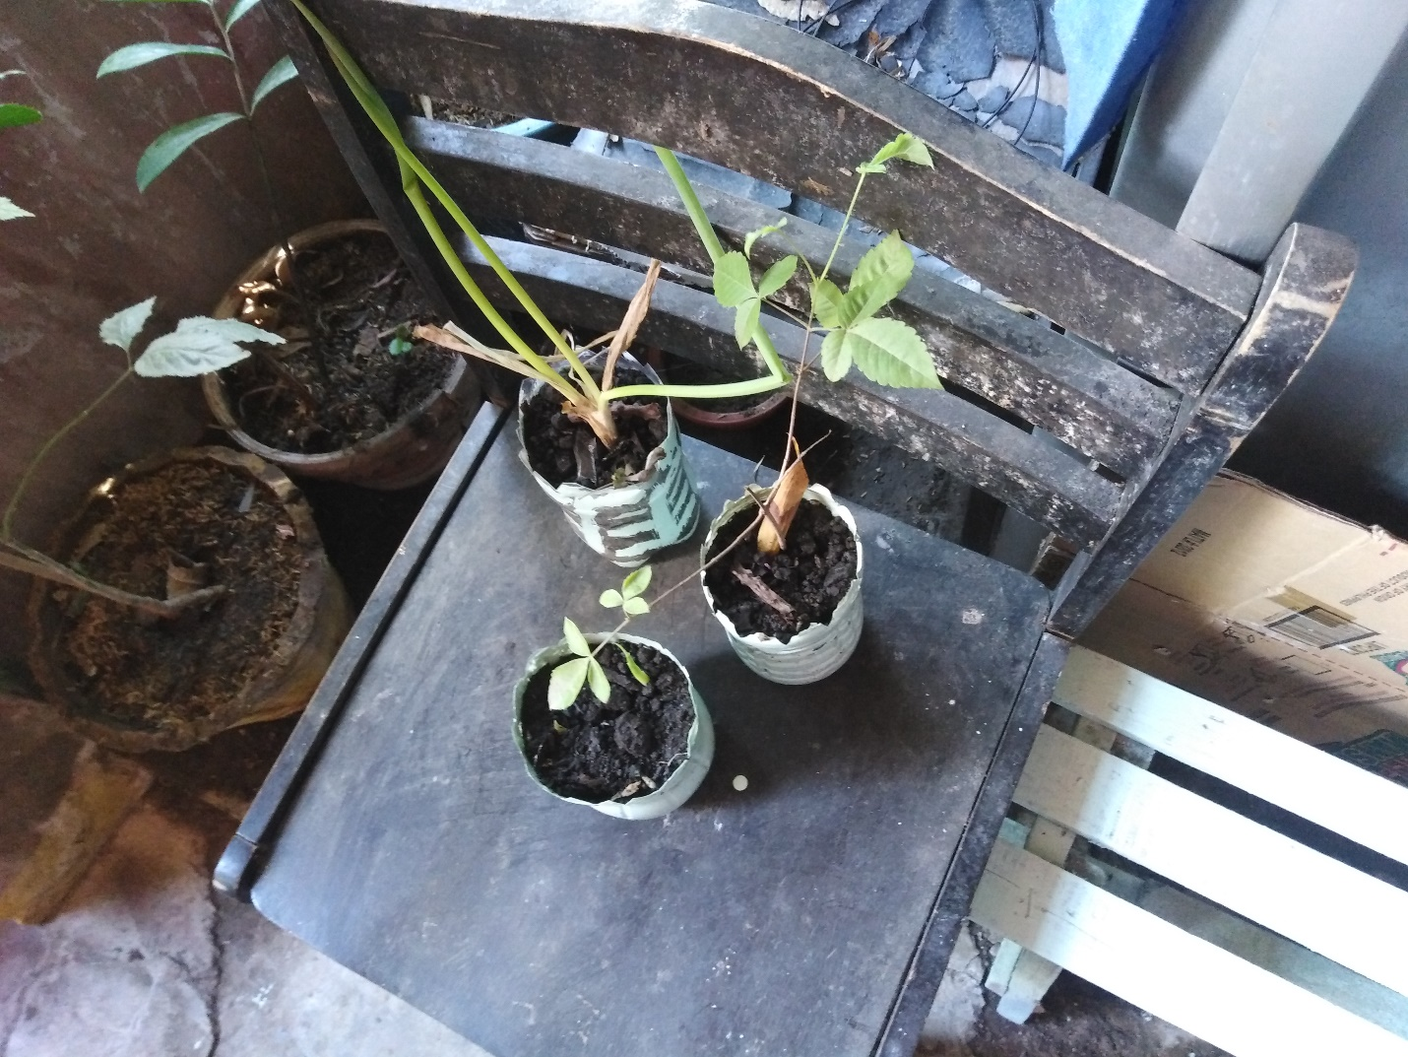

Green Onion

Ginger

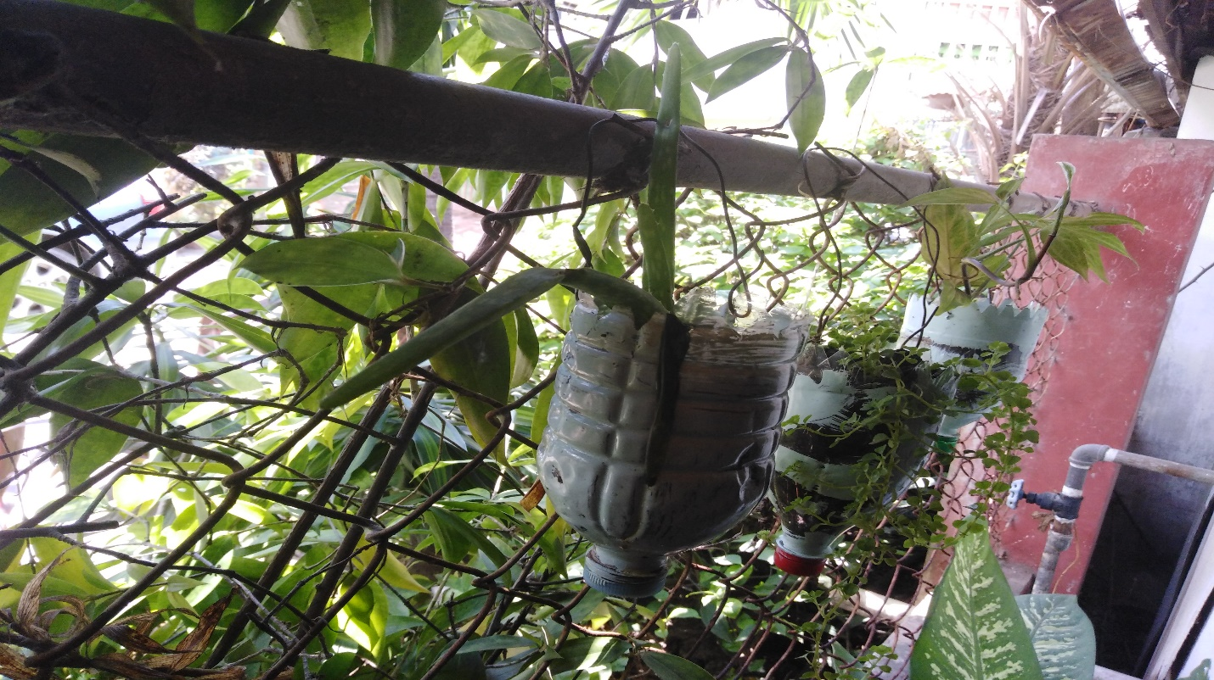Herbal

Aloe Vera

Lagundi

Ornamental

Gabi – Gabi

Hanging Plant

Week 4

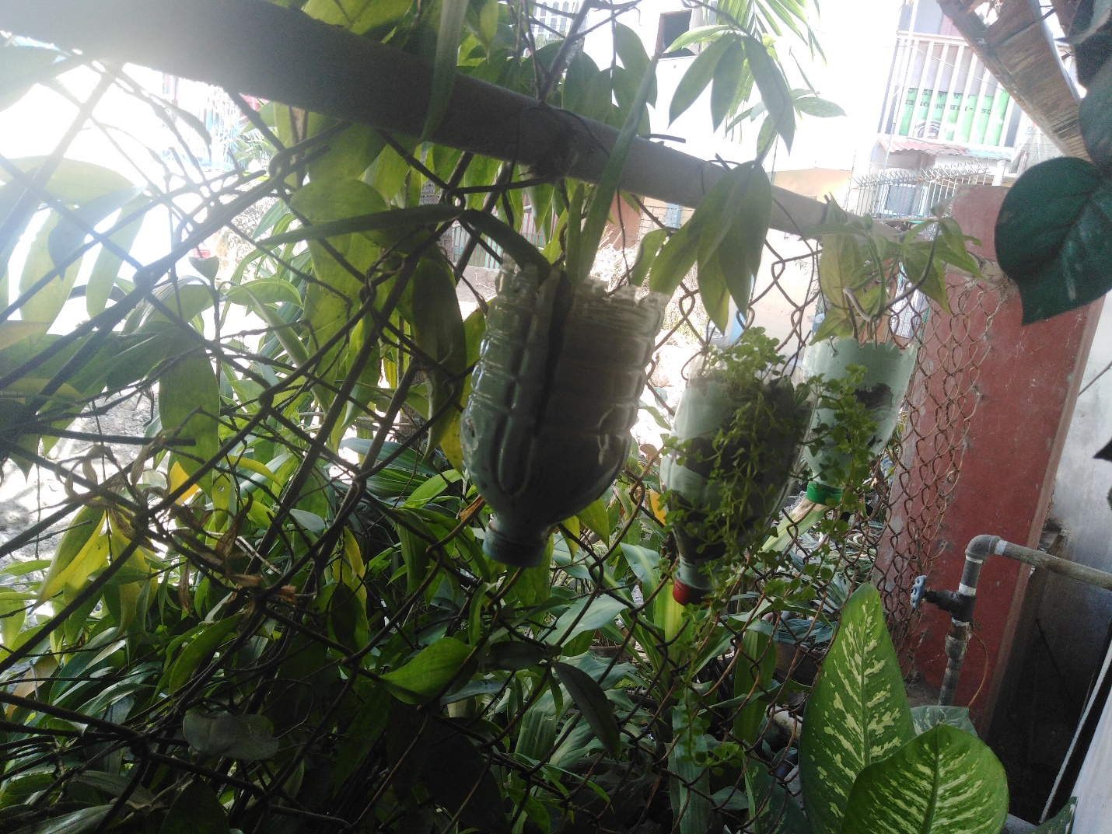Herbal

Aloe Vera

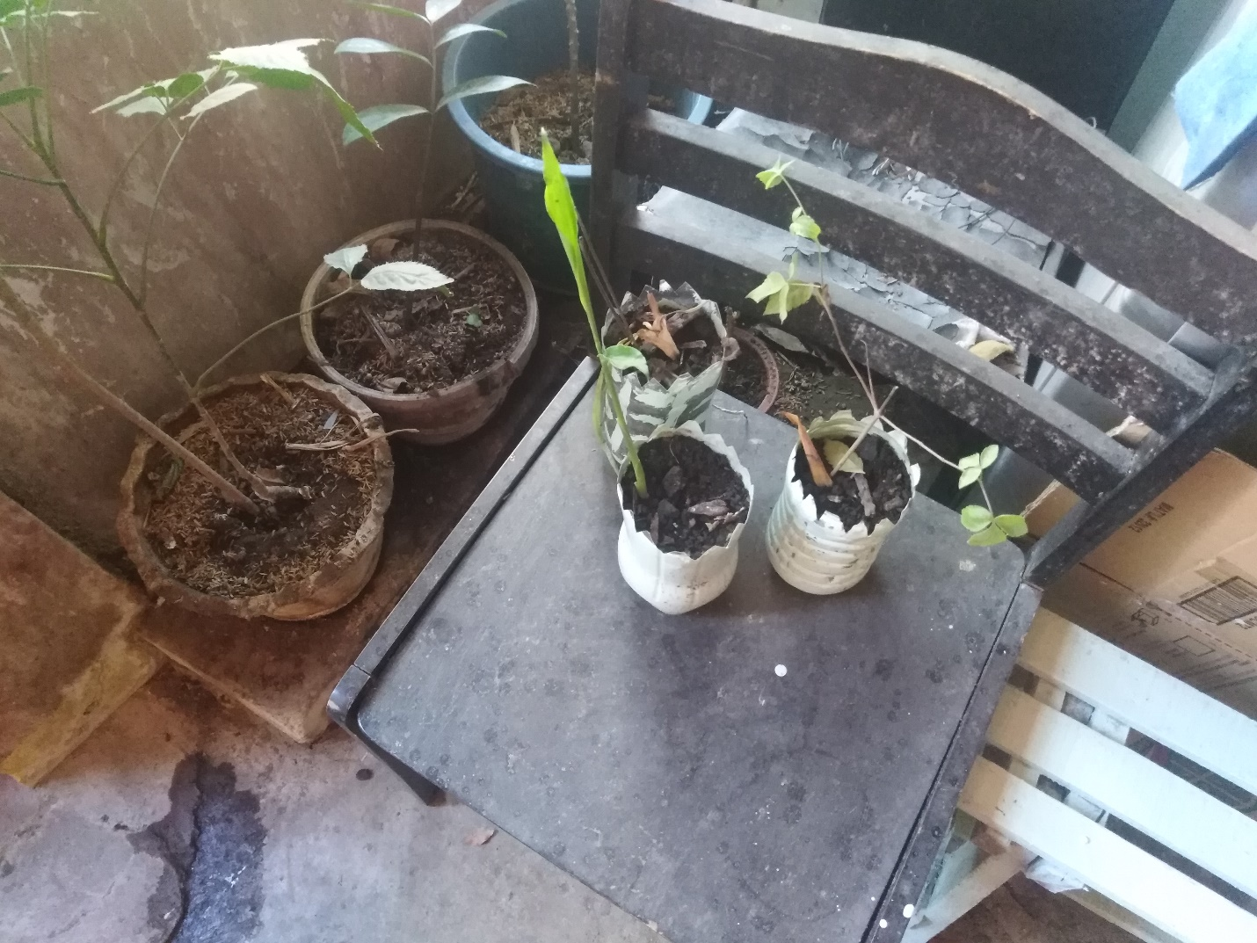

Lagundi

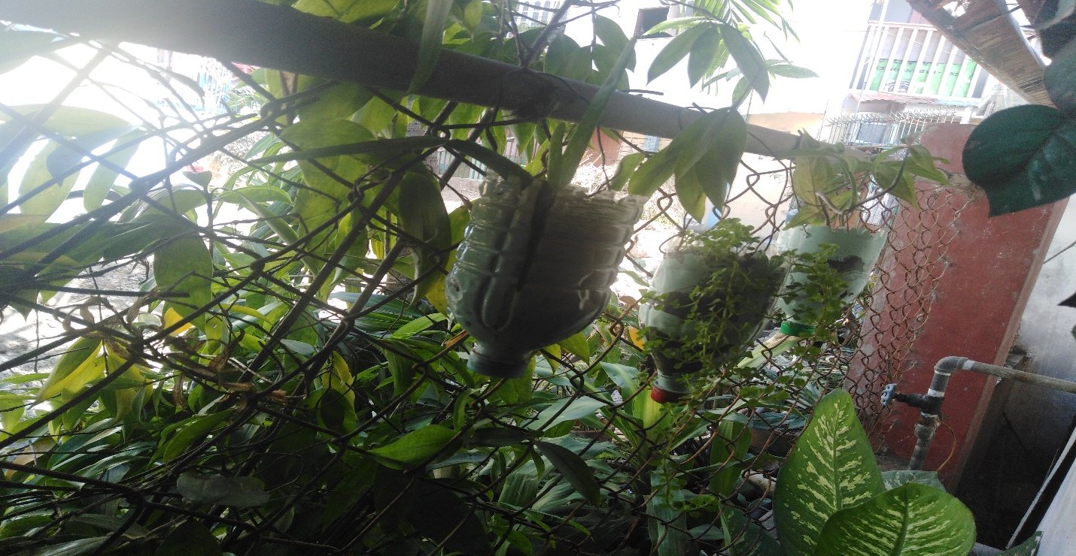Ornamental

Gabi-gabi

Hanging Plant

Spices

Green Onions

Ginger